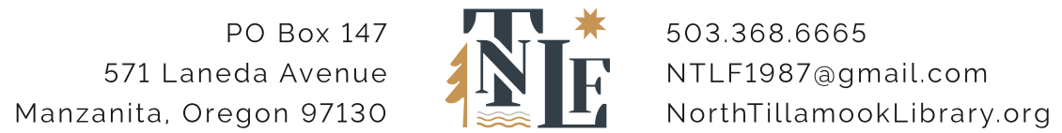
ANNUAL MEETING AGENDA
NORTH TILLAMOOK FRIENDS
January 20, 2024, 3 pm
Join us in the Library or via Zoom

Welcome and Introductions – Betsy Chase

Consent Agenda – Betsy Chase
- Minutes of November 13, 2023 Board meeting
- Library Friends 2024 annual calendar

Review of 2023
- Highlights – Betsy Chase
- Financial Performance – Bob Riecke
- Investment Performance – Craig Nern
- Membership – Barb and Michael Gould

Tillamook County Library Update – Don Allgeier

Business Items –
- Approval of Amendment to Bylaws – Steve Brier
- Election of Directors – Steve Brier
- Election of Officers – Steve Brier
- Approval of Board Signatories for 2024 and form resolutions from D. A. Davidson and 1st Security Bank authorizing approved signatories– Steve Brier
- Approval of 2024 Budget – Bob Riecke

Other business/announcements

Adjourn

